MS2040_01 Introduction to crystal structures and diffraction theories

Homework #6 Due: 11/27 after class

You are encouraged to organize a study group to solve the problem set.

1. Suppose we have a center rectangular lattice as shown in Fig. 1 (a:b = 3:2). Construct the reciprocal lattice of the center rectangular lattice using the dark-green cell (primitive cell). Pay attention to the angle of your reciprocal lattice.

2. Please construct the reciprocal lattice of the rectangular lattice using the dark-blue cell (double cell). Then, compare this reciprocal lattice with the one obtained in the previous problem. What is the differences?

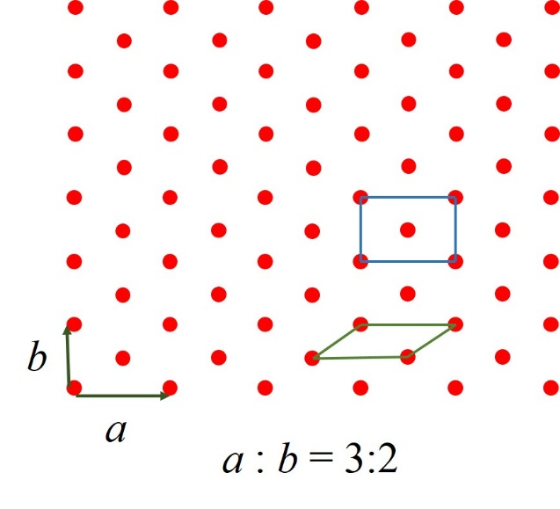
Figure 1.

