MS2040_01 Introduction to crystal structures and diffraction theories

Homework #5 Due: 11/20 after class

You are encouraged to organize a study group to solve the problem set.

1. Suppose we have two slits at a distance *A* apart and each has the width *B*. One can describe the system as

; (look at following picture!)

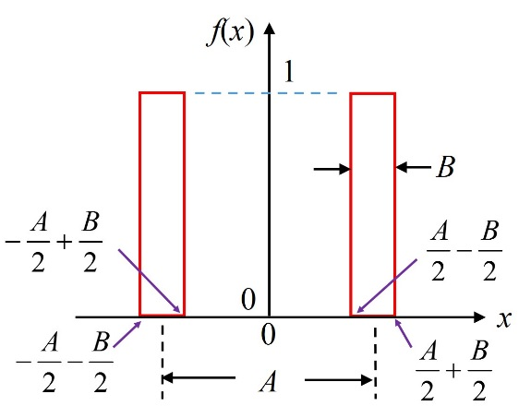

Please find the Fourier transform of *f*(*x*).

2. Please prove that the Fourier transform of is (2*iu*)3*F*(*u*), where *F*(*u*) is the Fourier transform of *f*(*x*).