MS2040_01 Introduction to crystal structures and diffraction theories

Homework #4 Due: 11/13 after class

You are encouraged to organize a study group to solve the problem set.

1. Derive the intensity of diffracted beam for a set of double-slit shown below, and plot the result for the cases of (a) a = 2b and c = 2a and (b) a = 4b and c = 4a.
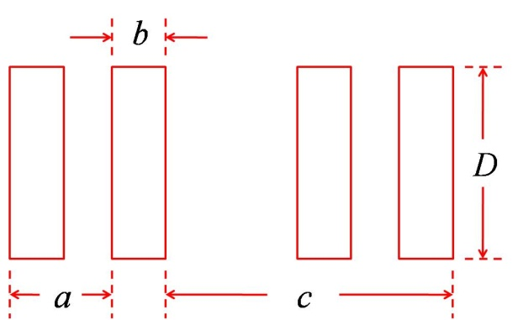

Where D >> a, c > b; D is the height of a slit; a is the adjacent spacing within the double-slit; b is the width of a slit; c is the spacing between double-slits.

Please use Huygens-Fresnel principle to start with.

2. Follow the above problem! If we extend the double-slit to N sets, i.e. there are N set of double-slit each spaced by c. Derive the intensity of diffracted beam for this case!

