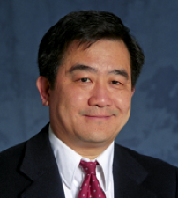
Alex Jen is currently serving as the Boeing-Johnson Chair Professor and Chair of the Department of Materials Science & Engineering at the University of Washington, Seattle. He is also serving as Chief Scientist for the Clean Energy Institute endowed by the Washington State Governor. He received his Ph.D. degree from the University of Pennsylvania in 1984 under the tutelage of Prof. Michael Cava.
Dr. Jen’s research interest is centered on utilizing molecular, polymeric and biomacromolecular self-assembly to create ordered arrangement of organic and inorganic functional materials for photonics, opto-electronics, nanomedicine, and nanotechnology. He has co-authored more than 560 SCI papers, given over 450 invited presentations, and has >26,000 citations and an H-index of 84. He is also a co-inventor for more than 50 patents and invention disclosures.
For his pioneering contributions in organic photonics and electronics, he was elected as Fellow by several professional societies including AAAS, MRS, ACS, PMSE, OSA, and SPIE. He has also been appointed as the National 1000 Talent Chair Professor at Zhejiang University, the Changjiang Endowed Chair at Wuhan University by the Chinese Ministry of Education, the World Class University Professor by the Korean National Research Foundation, and as the Distinguished Chair Professor by the National Taiwan University. Recently, he has been elected as an Academician by the Washington State Academy of Sciences.

