All-Optical Helicity-Dependent switching
in magnetic nano-structures and devices

M. S. El Hadri¹, R. Medapali², G. Malinowski¹, C.-H. Lambert¹, P. Pirro¹, S. Petit-Watelot¹, M. Hehn¹, E. E. Fullerton² and S. Mangin*¹

¹ Institut Jean Lamour, UMR CNRS 7198, Université de Lorraine, Vandœuvre-lès-Nancy, France
² Center for Magnetic Recording Research, University of California San Diego, La Jolla, USA

*stephane.mangin@univ-lorraine.fr
Abstract we present results of All Optical Helicity dependent Switching of the magnetization for different type of magnetic materials. We studied the influence of the material properties on the magnetization switching process. Hall cross have been used to study magnetization switching mechanism.
Introduction
Since Beaurepaire et al’s observation of ultrafast demagnetization in Ni films arising from a pulsed laser excitation [1], there has been a drive to understand the interaction between the ultrashort laser pulses and magnetization. These studies led to the discovery of the “All-Optical Switching” of magnetization in a ferromagnetic film alloy of Gd₂₂Fe_{74.6}Co_{3.4} using femtosecond laser pulses [2]. All Optical switching leads to a deterministic magnetization reversal of the material with no external magnetic field; the direction of the resulting magnetization is given by the right or left circular polarization of the light.
Body text
The manipulation of magnetization through laser beam had long been restricted to one material, though it turned out to be a more general phenomenon for a variety of ferromagnetic materials; including alloys, multilayers and heterostructures, as well as rare earth free synthetic ferrimagnetic heterostructures [3]. Recently, we have observe the same phenomenon in single ferromagnetic films as shown in figure 1, thus paving the way for an integration of the all-optical writing in storage industries [4].
The manipulation of magnetization through laser beam had long been restricted to one material, though it turned out to be a more general phenomenon for a variety of ferromagnetic materials; including alloys, multilayers and heterostructures, as well as rare earth free synthetic ferrimagnetic heterostructures [3]. Recently, we have observe the same phenomenon in single ferromagnetic films as shown in figure 1, thus paving the way for an integration of the all-optical writing in storage industries [4].
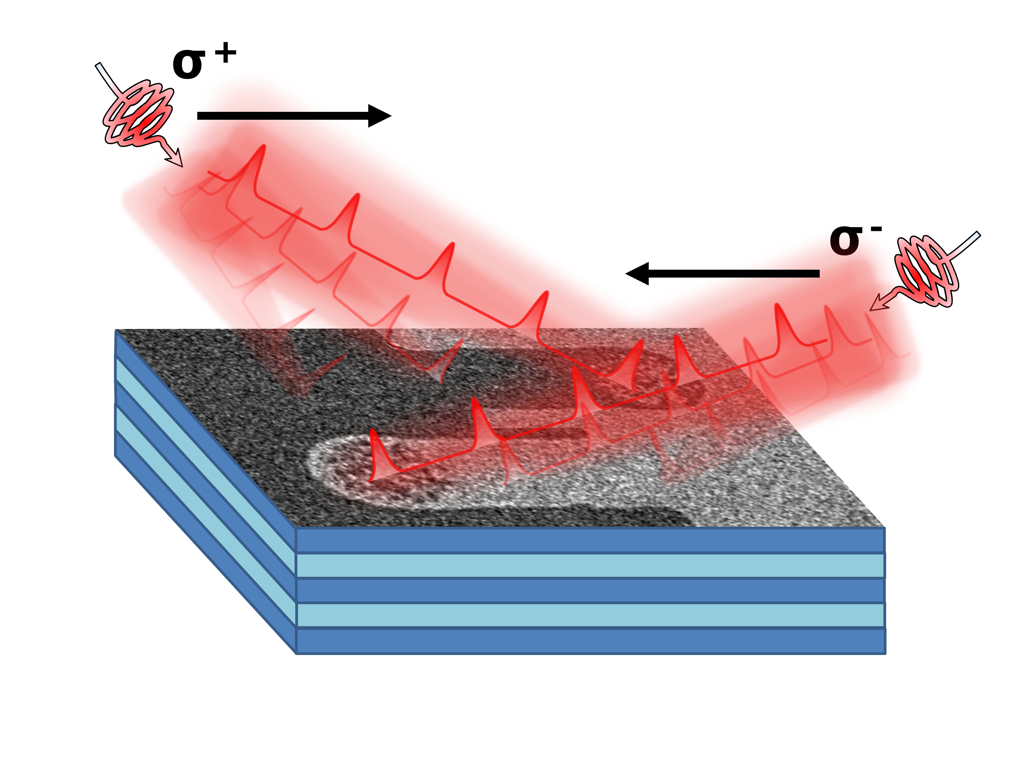
Figure1. Helicity dependent all-optical switching of a CoPt multilayer measured using Faraday microscopy.

It is within that context that we are studying the effect of femtosecond laser pulses on magneto-resistive systems with perpendicular magnetic anisotropy, with the aim of identifying the magnetization orientation through an electrical signal. We measure the all-optical switching in Pt/Co/Pt and Tb27Co73 based Hall crosses via the anomalous Hall effect. In fact, a jump in Hall voltage resulting from magnetization reversal is observed by reversing the circular polarization of the femtosecond laser pulses. This new way of probing the all-optical switching enables a statistical quantification of the switching ratio for different laser parameters. We study Hall crosses of ferrimagnetic and ferromagnetic materials. Our measures show also that the Tb dominant Tb27Co73 alloy becomes Co dominant due to the heating of femtosecond laser pulses.

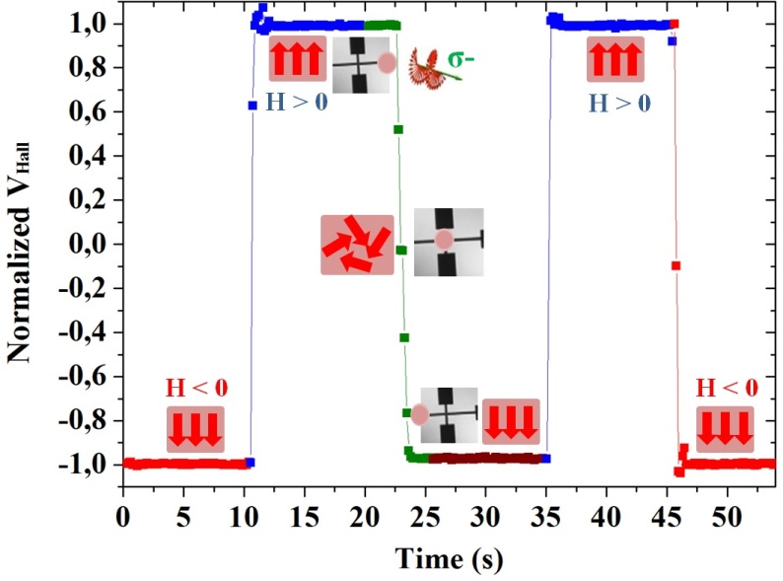

Figure 2: Magnetization switching measured via the anomalous Hall effect in Pt(3.7nm)/Co(0.6nm)/Pt(3.7nm) based Hall cross after sweeping with left-circularly polarized beam

References
[1] E. Beaurepaire et al, PRL 76 (22), 4250-4253 (1996)
[2] C. D. Stanciu et al, PRL 99, 047601 (2007)
[3] S. Mangin, et al, Nature Materials 13, 286-292 (2014)
[4] C-H. Lambert et al, Science 345 (6202), 1337 (2014)

