**nanostructures for flexible and High-performance optoelectronic devices**



Zhiyong Fan

Department of Electronic and Computer Engineering, Hong Kong University of Science and Technology, Hong Kong SAR, China

**Time:**2016/05/17(二) 15:10~16:10

**Place:**台達館401室

**Abstract**

Materials made of nano/micro-structures have unique physical properties, such as fast carrier transport, high surface-to-volume ratio, mechanical flexibility, sub-wavelength optical waveguiding, *etc*. These intriguing properties can be harnessed for a variety of applications in electronics and photonics. In the past, we have fabricated an assortment of semiconductor nanowires, including inorganic Si, Ge, ZnO, *etc*., and organic-inorganic perovskite nanowires. We have performed systematic investigations on their electronic and optoelectronic properties by configuring them as flexible transistors, photodiodes and sensors. Our investigations revealed that high performance photodetection can be achieved. One step further, we have achieved high density integration of these materials leading to fabrication of proof-of-concept image sensor devices with mechanical flexibility. In the meantime, we have also developed several self-organized approaches to fabricate three-dimensional (3-D) nanostructures. These 3-D structures have demonstrated geometry dependent photon management property thus have promising potential for photonic applications. In particular, we have fabricated 3-D nanopillar arrays, nanospike arrays and nanowell arrays. Optical absorption properties of these nano-engineered structures have been investigated with experimental methods as well as theoretical simulations. To explore their photonic applications, nanopillar and nanospike arrays have been fabricated into flexible photovoltaic devices. Our study has shown that they can demonstrate improved performance as compared to planar control samples, indicating their potency for cost-effective solar cells.

**Brief Biography**

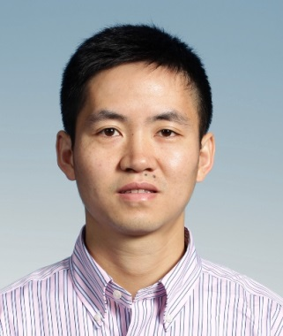Dr. Zhiyong Fan received his B. S. and M. S. degrees in Materials Science from Fudan University, Shanghai, China, in 1998 and 2001. He received Ph.D. degree from University of California, Irvine in 2006 in Materials Science as well. From 2007 to 2010, he worked at University of California, Berkeley as a postdoctoral fellow in department of Electrical Engineering and Computer Sciences, with a joint appointment with Lawrence Berkeley National Laboratory. In May 2010, he joined The Hong Kong University of Science and Technology (HKUST) and currently he is an associate professor in department of Electronic and Computer Engineering. Currently he is serving as a steering committee member of HKUST William Mong Institute of Nano Science and Technology, and a scientific committee member of HKUST Energy Institute. He also serves as an editorial board member of Nature Publish Group Scientific Reports and Associate Editor of Springer Nanoscale Research Letters. Dr. Fan’s research interest focuses on fabrication and characterization of nanomaterials and nanostructures, their applications for electronics and energy harvesting. He has published over 110 top referred papers on *Nature Materials, Nature Communications, PNAS, Nano Letters, Advanced Materials, etc.*, with close to 7,000 web of science citations.